İSİM : NATHANAELLE BOPTI NGAH BONG
ÖĞRENCİ NUMERASI: 24080410150

AVL – DSW – Self Adjusting Tree Uygulaması
Introduction
This project implements three different tree structures using the C# programming language. The project covers:
· AVL (Adelson-Velsky and Landis) Tree
· DSW (Day-Stout-Warren) Algorithm
· Self-Adjusting Tree

Dataset Used
Character sequence used in the project: S, E, L, İ, M, K, A, Ç, T, I . It is written in alphabetical order as follows A< Ç < E < I < İ < K < L < M < S < T.

Performed Operations
1. S inserted → Root: S
2. E inserted → Left of S
3. L inserted → RR imbalance → Right rotation applied
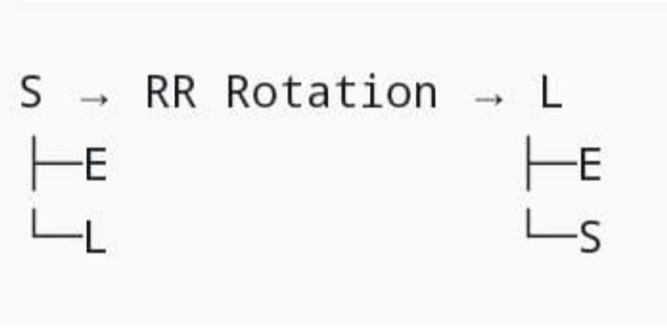
4. İ inserted → Right of L
5. M inserted → Right of L
6. K inserted → Left of İ
7. A inserted → Left of E → LR imbalance
E → LR Rotation → E
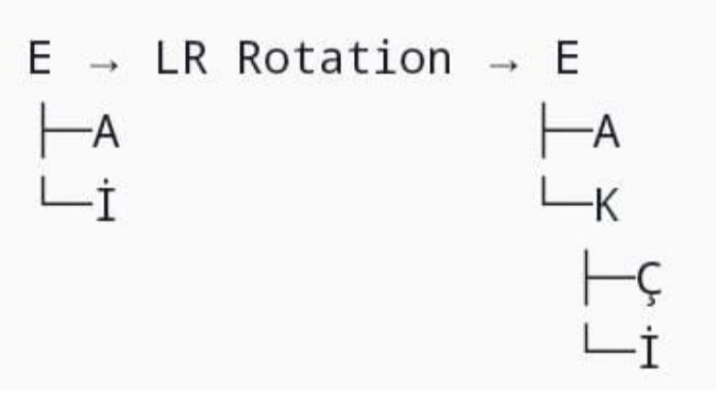
8. Ç inserted → Right of A
9. T inserted → Right of S
10. I inserted → Right of K

Final AVL Tree Structure

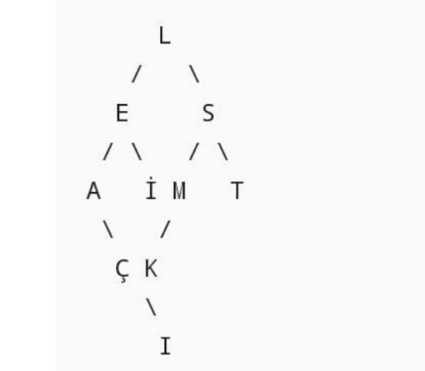
Expectations

- Root node: L (as expected)
- Leaf nodes: A, I, K, M, T (as expected)
- Tree height: 4
- Balance factor within ±1 for all nodes

DSW (Day-Stout-Warren) Algorithm

The DSW İS developed to "bring tree height to the minimum possible level.
Two Basic Steps of the Algorithm
- Right Rotation Chain (Backbone Creation): Convert tree to linked list (vine)
- Left Rotation Balancing: Convert linked list to balanced BST

DSW Implementation Process

A. Backbone Creation:
- Original AVL:
L-E-A-Ç-İ-K-I-S-M-T

- Backbone (vine):
A-Ç-E-I-İ-K-L-M-S-T

B. Balancing Steps:
1. n = 10, m = 7 (2^floor(log2(11)) - 1)
2. First phase: 10-7 = 3 left rotations
3. Second phase: m repeatedly halved with left rotations

Tree After DSW
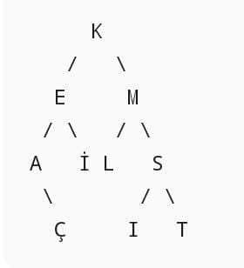

SELF ADJUSTING TREE

- Each node stores access frequency
- When an element is searched:
- Frequency value increases by +1
- Node moves closer to root
- Goal: Frequently accessed elements stay near root

Search Operations:

1. 'A' searched → Frequency: 0→1 → Moved closer with right rotation
2. 'L' searched → Frequency: 0→1 → Moved closer with left rotation
3. 'L' searched again → Frequency: 1→2 → Moved to root

Result: Most frequently accessed 'L' character became root node.

When the program runs, outputs of three phases are displayed sequentially:

1. Final AVL tree state and traversals
2. Tree structure before/after DSW
3. Self-adjust operations and final tree state

